Coding test SUBMISSION

**Web Developer Position- OPTUS**

Sonali Rajendra | 0468742071 | [sonali.gc@outlook.com](mailto:sonali.gc@outlook.com)

Contents

SCOPE 2

TECHNOLOGIES USED 3

ASSUMPTIONS and CONSTRAINTS 3

TEST CASES AND RESULTS 4

TESTED CODE 6

CODE ACCESS in JSFIDDLE 6

# SCOPE

|  |  |
| --- | --- |
| **SCOPE ITEM** | **STATUS** |
| 1. Behavior | Complete |
| 1. .Multiple bars | Complete |
| 1. One set of controls that can control each bar on the fly | Complete |
| ·        4. Can't go under 0 | Complete |
| 1. Can go over 100, but limit the bar itself and change its colour   · | Complete |
| 1. Display usage amount, centred | Complete |
| 1. Write tests for your code (hint: TDD strongly preferred) | Complete |
| 1. Implement a responsive solution: testing it on mobile, tablet, etc. Getting it working nicely. | Complete  Responsive design implemented in 2 ways in 2 files :   1. Using Bootstrap 2. Using CSS Media Queries |
| 1. Animate the bar change, make sure it works well when you tap buttons quickly. | Complete |
| 1. Publish your code online somewhere: GitHub or something like [plnkr.co](http://plnkr.co/), [jsfiddle.net](http://jsfiddle.net/) | Complete |

# TECHNOLOGIES USED

|  |  |
| --- | --- |
| **Feature** | **Technology Used** |
| **Generating the Progress Bar and other UI Components** | HTML 5 |
| **Handling the User Events** | Jquery+ JavaScript  Used to Handle the button Clicks as a controller  & For Writing Services for each Progress Bar Processing |
| **Style** | CSS3 |
| **Responsive Design + Buttons / Select Reentering** | Twitter Bootstrap |
| **Unit testing** | Jasmine |
| **Editor** | Sublime |
| **Code Publishing** | JS Fiddle : Link  https://jsfiddle.net/sonaligc/pkuqaz0x/1/# |

# ASSUMPTIONS and CONSTRAINTS

1. Number of Progress Bars=3 and buttons =4 to add values {+25,+10,-25,-10}
2. Max limit of each Progress bar=100,minimum=0
3. Responsive design has been implemented in 2 ways (Bootstrap and CSS3 Media Queries in 2 separate files)

[ Please verify with the Bootstrap version since the CSS Media Queries needs fine tuning for better performance and is not up to mark due to time constraints]

Solution Constraints:

1. ***On Chrome/JS fiddle, the color change from green to red on 100% completion of progress bars is not visible. The same works with IE perfectly.
2. The progress indicator is displayed in a separate label outside the progress Bar.
3. The Solution works best on IE

# TEST CASES AND RESULTS- AS TESTED iN IE

1. Initial State

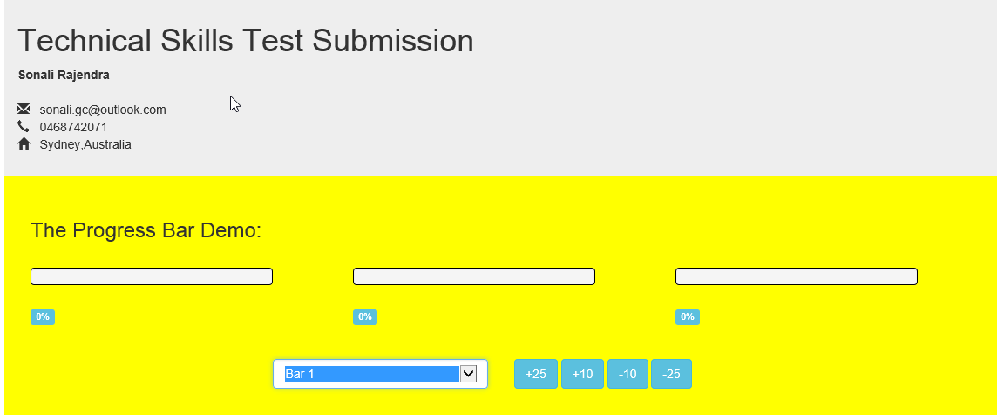

1. On 100% completion

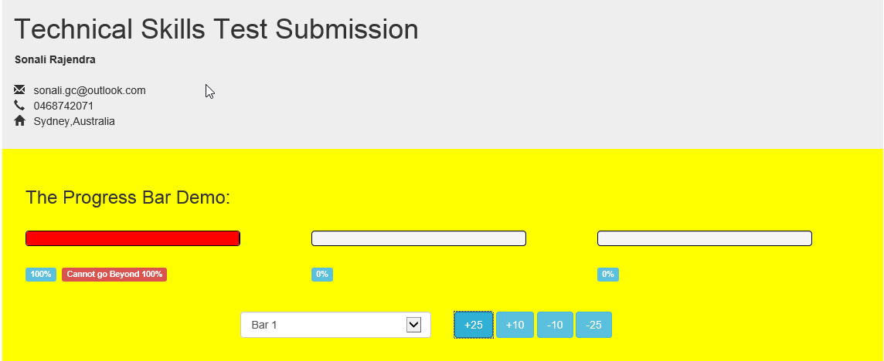

3. When Progress Bar 3 reaches 0 or less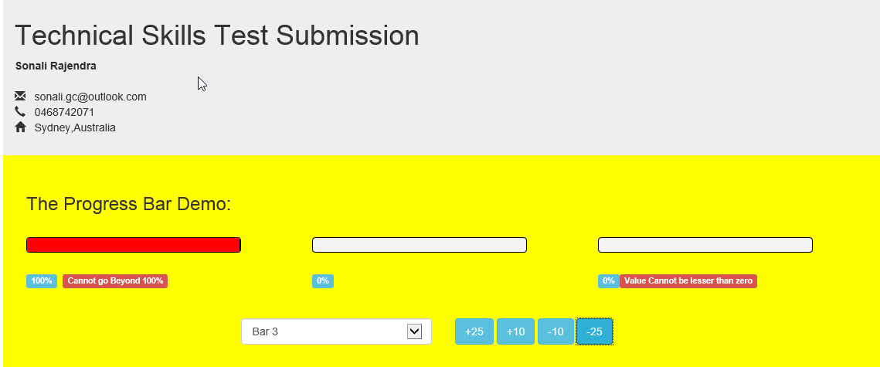

4. Random value Change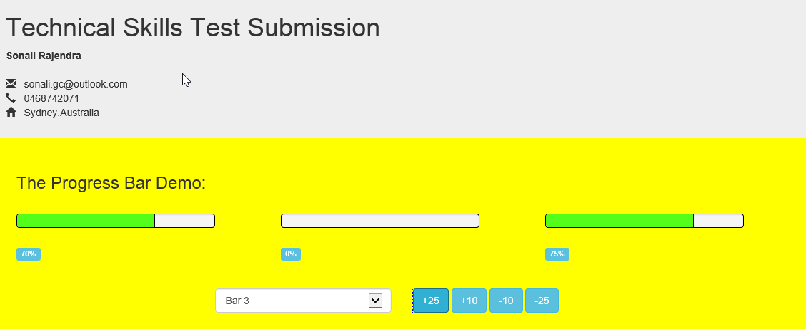

5. On resizing the window to emulate a Mobile Screen

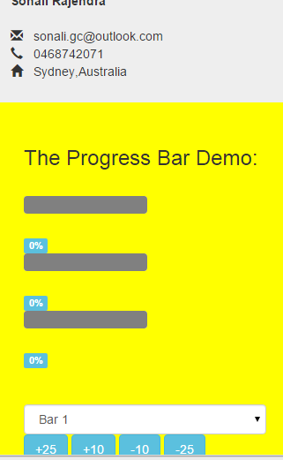

# TESTED CODE

|  |  |
| --- | --- |
| JS File |  |
| HTML File using Bootstrap |  |
| HTML File using plain Responsive Design |  |
| Minified JS File |  |
| CSS File |  |
| Unit testing |  |

# CODE ACCESS in JSFIDDLE

LINK TO CODE in JS FIDDLE :

https://jsfiddle.net/sonaligc/pkuqaz0x/1/#

